CASE STUDY 4 Employee Payroll and Deduction Analysis
- Problem Statement
Calculate an employee's gross salary from basic pay, allowances, and overtime, then apply deductions and print a salary statement.
2. Objectives
Practice arithmetic expressions and formatted output.
Use conditions to apply a deduction rule.
Compute net salary.
3. Assumptions
HRA is 20% of basic pay.
DA is 10% of basic pay.
Overtime pay is ₹200 per hour.
Deduction is 8% of gross salary when gross salary is above ₹30,000; otherwise 5%.
4. Algorithm
1. Read employee name, basic pay, and overtime hours.
2. Validate that basic pay and overtime hours are non-negative.
3. Calculate HRA, DA, and overtime pay.
4. Calculate gross salary.
5. Choose the deduction percentage based on gross salary.
6. Calculate net salary and print the payslip.
5. Flowchart
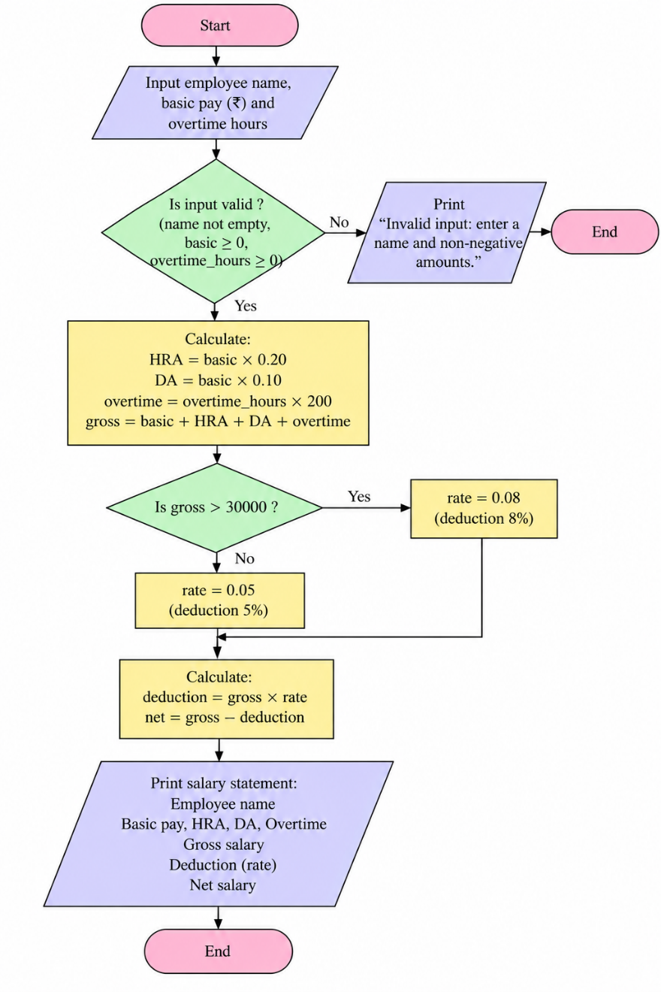
6. Pseudocode
START
INPUT name, basic, overtime_hours
IF basic < 0 OR overtime_hours < 0: PRINT invalid; STOP
hra = basic * 0.20
da = basic * 0.10
overtime = overtime_hours * 200
gross = basic + hra + da + overtime
rate = 0.08 IF gross > 30000 ELSE 0.05
deduction = gross * rate
net = gross - deduction
PRINT payslip
END
8. Test Cases
Test | Input / Scenario | Expected result
1 | Anu, basic 20000, overtime 5 | Gross ₹27,000.00; deduction ₹1,350.00; net ₹25,650.00
2 | Ravi, basic 30000, overtime 10 | Gross ₹39,000.00; deduction ₹3,120.00; net ₹35,880.00
3 | basic -1 | Invalid input message
9. Output Screenshot
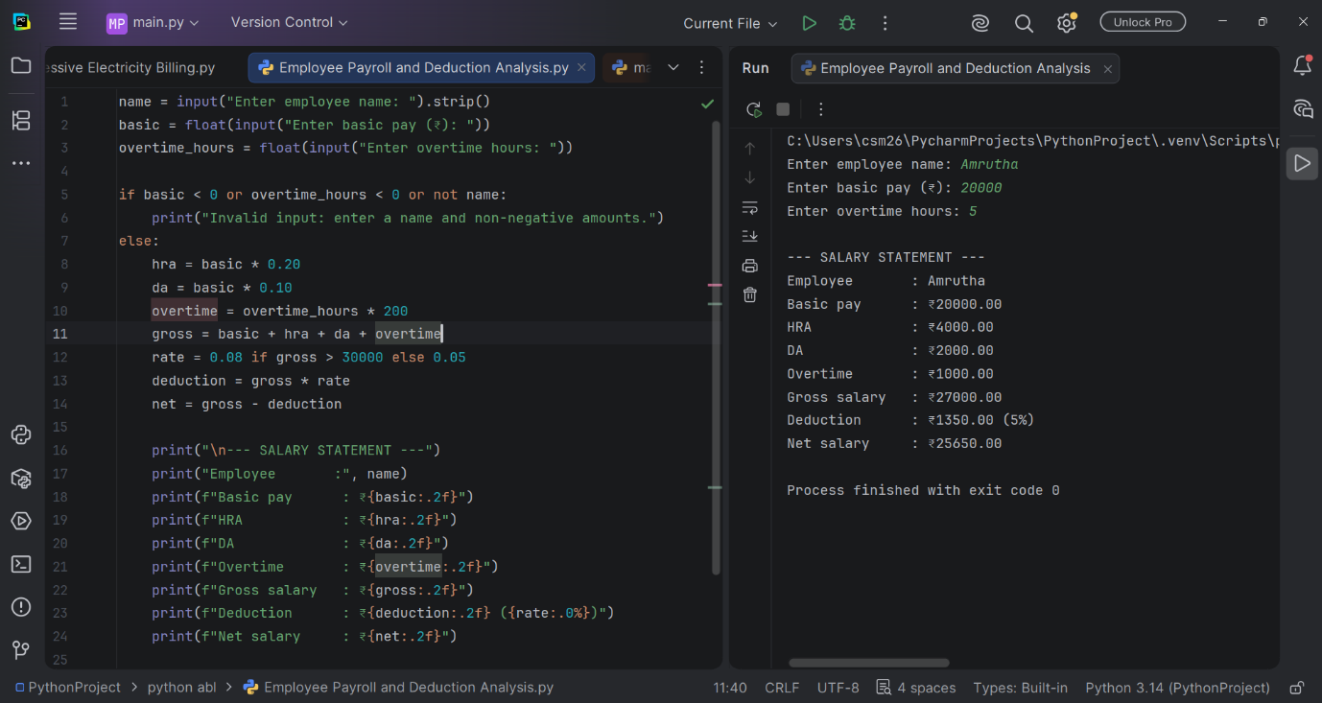
10. Conclusion
The program generates a salary statement and applies a deduction rate based on the calculated gross salary.

